2026
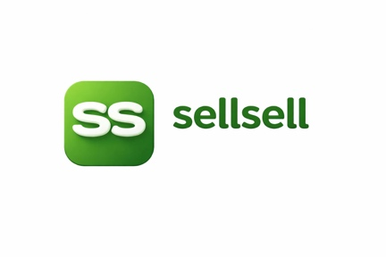
sellsell marketplace updates:

Shaz EJ

SellSell / PickPic Project Progress Report

Date: 20 June 2026

Executive Summary
The platform has reached a major milestone.
Over the past few days, we focused on resolving the last critical production issues and stabilizing the core marketplace experience. All identified production blockers have now been fixed, deployed, and verified on the live environment.
The platform is currently estimated at approximately 95% completion and is ready for demonstrations and controlled user testing.

Major Issues Resolved

1. User Logout Issue (Resolved)
Issue:
Some users were being logged out unexpectedly due to authentication refresh conflicts.
Resolution:
The authentication architecture was corrected, eliminating duplicate session refresh operations.
Result:
- Stable login sessions
- No unexpected logouts
- Improved reliability across all pages
Status: Completed

2. Admin Dashboard Crash (Resolved)
Issue:
The Admin Dashboard was crashing due to a form context rendering error.
Resolution:
The dashboard filters and form components were corrected and deployed.
Result:
- Dashboard loads successfully
- Filters operate correctly
- User management pages are accessible
Status: Completed

3. Explore Page Recommendations Error (Resolved)
Issue:
Personalized recommendations were failing to load due to data parsing issues.
Resolution:
Recommendation processing logic was corrected and deployed.
Result:
- Recommendations now load successfully
- Improved user discovery experience
- Stable Explore page
Status: Completed

Production Verification
Comprehensive browser testing was performed on the live production environment.
Verified Areas:
- User Login
- Session Persistence
- Explore Page
- Product Recommendations
- Seller Flow
- Admin Dashboard
- Navigation Between Pages
Result:
All critical production tests passed successfully.
Production Status:
READY FOR DEMO

Current Platform Completion

Completed
- AI Search Engine
- Semantic Search
- Arabic and English Search
- AI Listing Generation
- AI Product Description Generation
- AI Moderation Pipeline
- Qdrant Vector Search
- Demand Capture System
- Seller Marketplace Flow
- Buyer Marketplace Flow
- Authentication System
- Recommendation Engine
- Production Infrastructure
- RunPod AI Integration
- Ollama Integration
- Docker Deployment
- Redis Queue System
- Background Processing
Estimated Completion:
95%

Remaining Work

Admin Dashboard Enhancements
Current Status:
Approximately 60%
Remaining:
- Moderation Management
- Demand Capture Analytics
- Search Analytics
- User Analytics
- Operational Monitoring
Estimated Time:
2–4 Days

Notification System
Current Status:
80%
Remaining:
- Email Notifications
- Push Notifications
- Notification Preferences
Estimated Time:
1–2 Days

Mobile Application Improvements
Current Status:
70%
Remaining:
- Seller Listing Management
- Performance Improvements
- User Experience Enhancements
Estimated Time:
3–5 Days

Final QA and Performance Testing
Remaining:
- Load Testing
- Security Testing
- Stress Testing
- Production Monitoring
Estimated Time:
2–3 Days

Recommended Next Priority
- Complete Admin Dashboard
- Complete Notification System
- Complete Mobile Enhancements
- Perform Final QA
- Begin Controlled User Testing

Overall Assessment
The difficult engineering work is now largely complete.
The remaining work is focused on:
- Administration tools
- Notifications
- Mobile polish
- Final testing
The marketplace core, AI search engine, AI moderation pipeline, recommendation system, and production infrastructure are already operational.
If development continues at the current pace:
- MVP can be finalized within approximately 1 week.
- Commercial launch preparation can begin immediately after QA.
- Advanced AI agent features can be added during the following months without changing the core architecture.
Current Project Status:
95% Complete
Production Status:
Stable
Demo Readiness:
Ready

